Irwan Syahputra (BE-12)

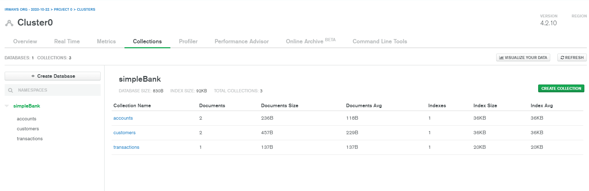

Collection

Insert Multi customers

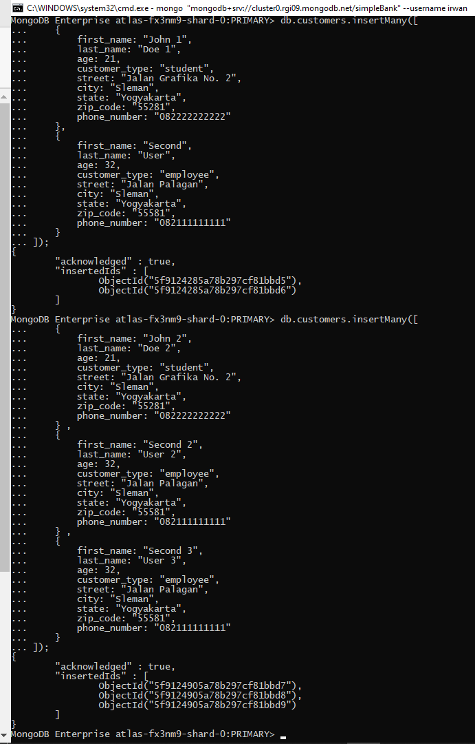

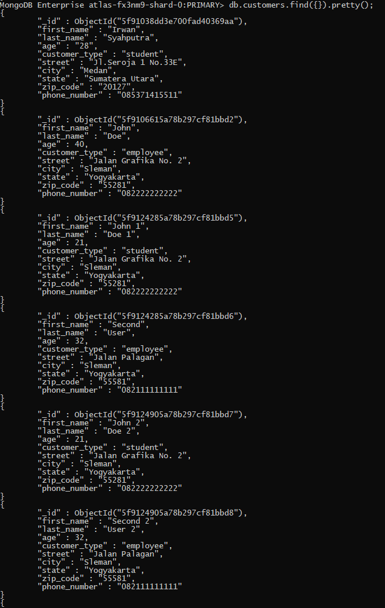

Select All Custemers Collection

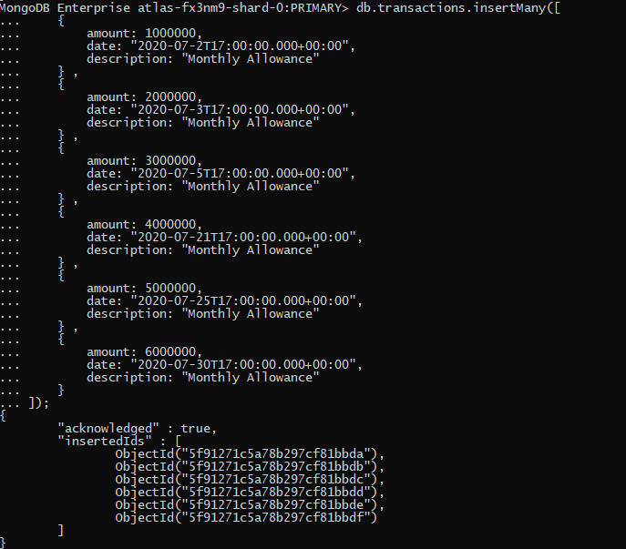

Insert Transactions Multi

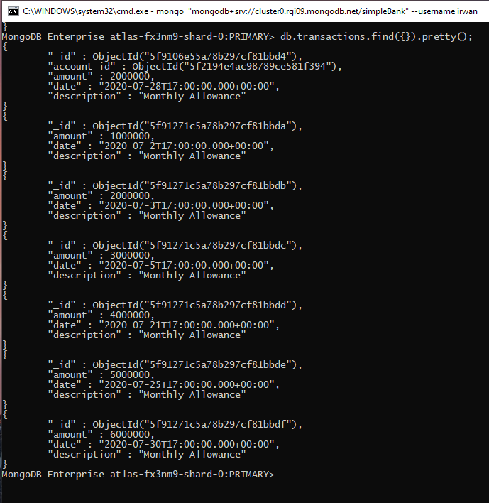Select transactions

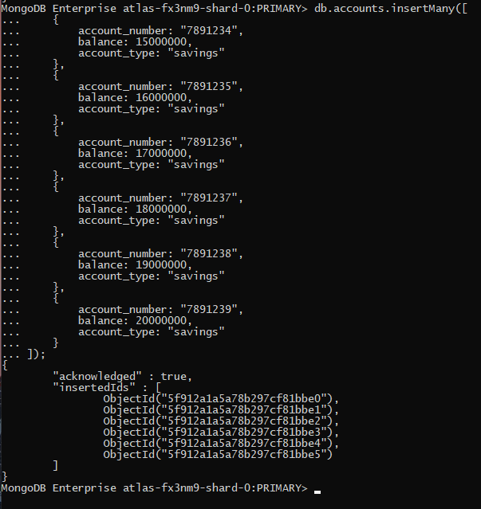

Insert Account Multi

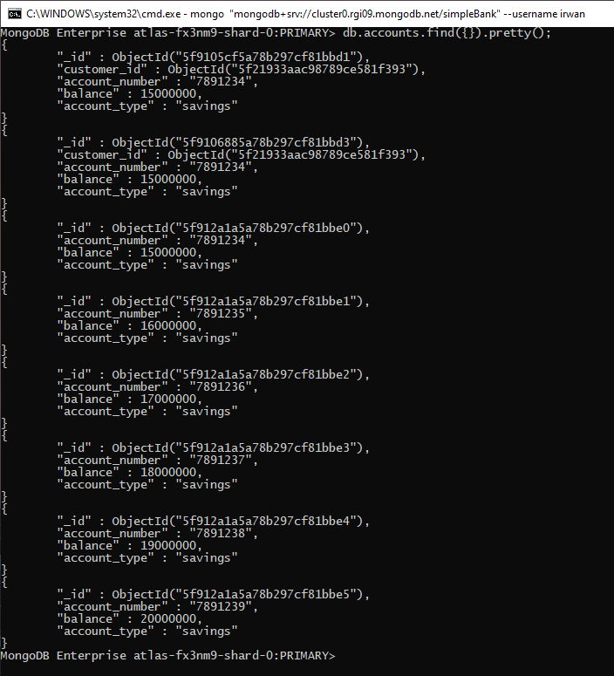

Select Account

|  |  |
| --- | --- |
|  |  |
| Before | After  Update Customer set customer_type=”mahasiswa/i” where age >21; |
|  | db.customers.updateMany( { age: { $gt: 21 } }, { $set: { customer_type: "mahasiswa/i" } }, ); |

|  |  |
| --- | --- |
|  |  |
| Before | After  Delete from accounts where balance > 15000000; |
|  | db.accounts.deleteMany({ balance: { $gt: 15000000 } }); |

|  |  |
| --- | --- |
|  |  |
| Select * from accounts; | Select * from accounts where account_number=”7891234” |
| db.accounts.find().pretty(); | db.accounts.find({account_number: "7891234"}).pretty(); |

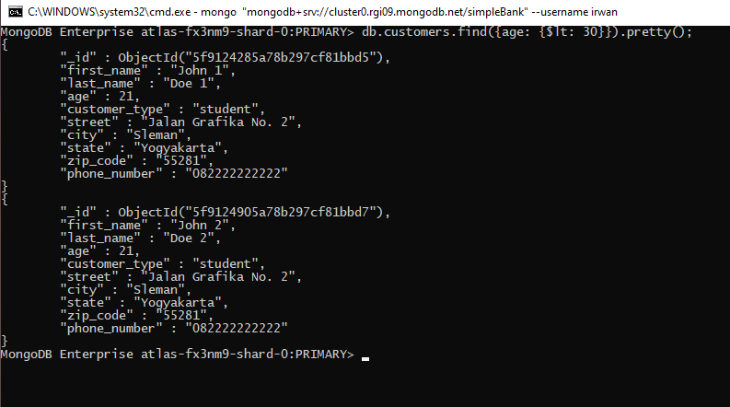

Select * from customers where age <30; =>> db.customers.find({age: {$lt: 30}}).pretty();

|  |  |
| --- | --- |
|  |  |
| Data Account | Data Customers |

|  |
| --- |
| Multi Collection Join |
| Display account list detail with customer |
| Select * from accounts a inner join customers b on a.customer_id = b._id |
|  |

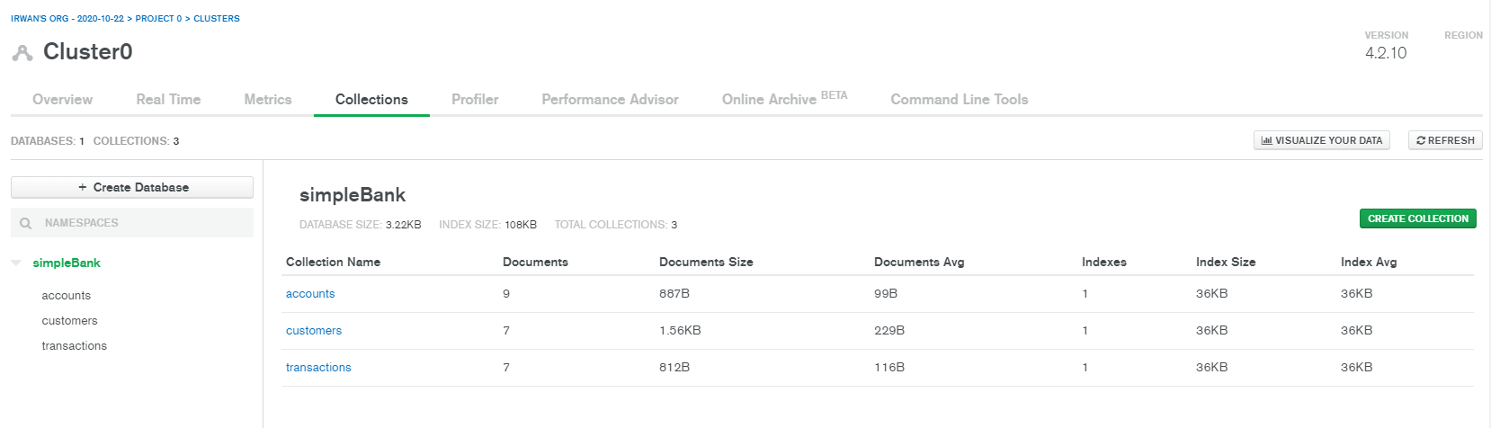

All Collection Size